# BDD -

Bdd is not a framework. Bdd is a process. We don’t write some bdd code etc etc.

Extension of tdd.

Test centric approach.

It’s a methodology or process.

All three amigos prepare documentation and come to common understanding of feature file, in form of gherkin or “given when then” format.

Many tools/libraries/frameworks in market to implement bdd process like cucumber, jbehave, rspeck etc with java, python etc.

Data driven is not a framework, it is an approach.

Similarly, keyword driven is an approach.

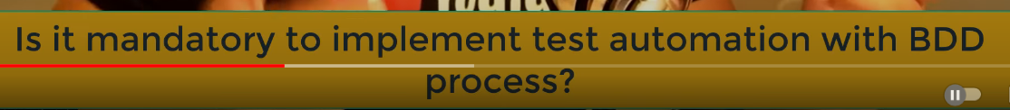

# Ocd-

Answer is no.

# Interview answer when using bdd-

We are doing automation. Bdd process followed. To implement the process we use cucumber framework alongwith selenium java or python library.

Why we picked bdd?

Common understanding amongst the team what process to follow.

Writing of feature files is also agreed upon mutually.

Reviewing if all features covered.

All work together in a team.

Bdd is collaborative process among three amigos – dev, qa, po/ba/other stakeholders.